Dot net core is a free **open source** and **cross platform framework**, created for building modern cloud based application.

**Open source and close source**

In general, open source refers to any program whose source code is made available for use or modification.

**ASP.net Core Featurs**

1. Cross platform, open source
2. Fast development – fast work over the browser
3. Work in your editor – now you can work not in **Visusal Studio**. You can also choose **Visual Studio code.**
4. It is based on **Model-View-Conroller(MVC)** architecture.

**What is ASP.NET Core**

1. ASP.Net core is a new version of ASP.NET, developed by mircrosoft.
2. It is an open-source framework for developing **web applications** and it can be run on Windows, MAC or Linux.
3. Before ASP.Net Core, Microsoft alreay had 2 other similar framework, these were- ASP.NET Web Form and ASP.Net MVC.
4. The latest version of ASP.Net Core is ASP.Net Core 7.0 released on feb 24, 2023.

**ASP.net Core (for web application)** and **.net core (frame work)** both are different

ASP.net Core 6 ---base on-> .net 6

ASP.net core 3 ---base on -> .net core 3

ASP.net core 4 ---base on -> .net core 4

ASP.net core 5 ---base on -> .net core 5

**Pre-Requisite**

1. HTML
2. CSS
3. JavaScript
4. Bootsrap
5. C# Programming Language(object oriented programming)
6. MVC
7. Visual Studio 2017 or higher version

We use Visual Studio 2022 (community version)

**Difference between .net framework and .net core framework**

**.net framework**

1. .net framework is a programming framework created by Microsoft to create application more easily. A framwork is just a bunch of code that the programmer can call without having to write it explicitly.
2. It is basically a collection of libraries.
3. It has a number of pre-coded solutions that manage the execution of programs written specifically for the framework.

**Difference**

.net framework .net core framework

. old framework . new framwork

. not open source . open source

. only for windows plateform . cross platform (win, linux, mac)

**Difference between ASP.NET and ASP.NET Core**

**MVC**

MVC is not a programming language, MVC is not a framework, it is a design pattern and according to this pattern we design our application.

**MVC with ASP.NET Core**

Three basic components of MVC

1. Model (business entities)(database entities)
2. View (HTML pages)
3. Controller (Business logic) comnunication between modle and view.

**MVC Work Flow**

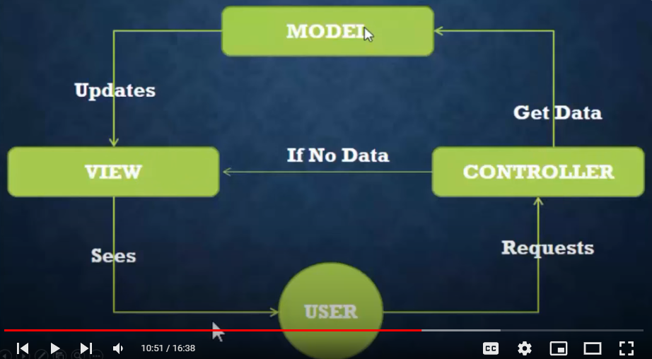



**How to setup Project with MVC or Without MVC**

**Folder Structure**